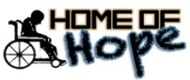

HOME OF HOPE JINJA UGANDA

|  |  |  |  |
| --- | --- | --- | --- |
|  |  | P.O. Box 5047, Jinja- Uganda  Mob: +256772183058  Office line 0393217663  email: [edith.homeofhope@outlook.com](mailto:edith.homeofhope@outlook.com)  [www.](http://www.)homeofhopeuganda.org |  |

**MONTHLY PERFORMANCE REPORT FOR SEPTEMBER 2021**

**PERFORMANCE AGAINST THE PLANNED ACTIVITIES FOR THE MONTH OF SEPTEMBER 2021**

**1ST OCTOBER 2021**

|  |  |  |  |
| --- | --- | --- | --- |
| **PLANNED ACTIVITY** | **TARGET** | **ACHIEVEMENT** | **LESSONS LEARNT,COMMENT, CHALLENGES AND WAY FORWARD** |
| Out reach | 1 in Buwenge Sub County | 9 new patients were registered during the outreach. All the continuing patients reported stability in their health as a result of constant and proper uptake of medication while those who had developed setbacks also reported grate improvement in their health.  At total of 122 patients were attended to, 28 of whom were from the neighbouring districts of Luuka and Kamuli | There is need to step up on the home visits to ascertain the said conditions of the patients since some parents are un able to transport the children to the outreach point due to high transport costs and the bad terrain caused by the heavy rains. |
| Consultation Meeting | 1 (Busede Sub County) | Many of the would be beneficiaries of our programmes are unable to access services required due to the fact that they stay in hard to reach areas (Busede S/C being one of them) and as a result, a meeting with the stake holders at sub county was scheduled aimed at creating a way forward for possible intervention. The meeting was attended by the Sub County Chief, LC III Chairperson, Community Development Officer, Parish Chiefs and sub County Councillors. Together with the stake holders, we were able to develop strategies for possible intervention | It was resolved that a community dialogue to be held on 13th September 2021 involving all PWDs and care givers of children with disabilities residing in the Sub County.  Parish chiefs together with the Councillors were to carry out mobilisation of the intended target for the meeting.  Home of Hope staff to take the lead role during the dialogue based on the intended objectives of the dialogue |
| Community dialogue | 1 (Busede Sub County) | As a result of the consultative meeting, a community dialogue with PWDs and caregivers of Children with disabilities together with leaders of disability structures in the sub county was conducted and a total of 132 PWDs were assessed by Home of Hope staff.  5 children with saviour and complex conditions were referred to partner organisations such as One 4 another and Comprehensive Rehabilitation Services in Uganda (CorSU) for further management while 5 children with Hydrocephalus and 3 children with Spinal Bifida were facilitated to attain further examination and management at Cure children’s hospital. | A community outreach was scheduled for 15th October 2021 at the sub county headquarters.  Home of Hope to liaise with the partner organisations to enable the referred patients/ clients receive the necessary services.  Even though the meeting or outreach is to be conducted at the sub county level, some beneficiaries report of transport challenges in accessing the services.  Most of the caregivers and persons with disabilities lacked knowledge of their current conditions and how to manage it. |
| Referrals | 5 children | During the period under review, 13 children with complex conditions were referred to other partner organisations/ institutions for further management and those who presented with saviour Hydrocephalus, Spinal Bifida were referred to Cure children’s hospital | Due to financial constraints, the referred patients could not make it to necessary designations and Home of Hope had to cater for their transport to these places.  Some of the referred patients have not given feedback of the referrals due to communication challenges and is need for follow up at household level by Home of Hope staff. |
| Centre General clinic | 1 per month (60 patients) | A total of 109 patients were attended to, 4 new clients were received and registered. All patients attended to reported positive response to the medication received and few cases of seizures were reported by the patients | The low seizures were as a result of adhering to medication protocols and guidelines by the medical team.  Close monitoring at household level to be done by home of hope staff. |
| Medical Review | 9 children | 9 resident children with Hydrocephalus and spinal bifida were taken for medical review at Cure children’s Hospital - Kimaka out post and they were in stable condition. 1 child Living positively with HIV was also taken to Nalufenya Children’s Hospital and was fairing on well with medication  5 children from Busede were also facilitated for review at Cure children’s clinic in Kimaka under the community outreach programme. | New review dates were set for the different children. According to the reports, all the resident children were responding positively and were in stable condition.  One child from Busede was referred to Cure Children’s Hospital Mbale for further management |
| Drop in clinic | 4 (once a week) | 4 drop in clinic sessions were held within the month under review. Some of the children who have been on continuous therapy showed improvement in their mobility skills.  3 new clients were registered during the month of September two of whom have cerebral palsy and one with Autism. | There was a low turn up for the clinics due to heavy rains making the roads inaccessible.  Some clients also find it difficult to commute on a weekly basis hence skipping some days which has led to low recovery by the patients. |
| Home visits | 40 house holds | 32 households were visited in the month of September to ascertain the living conditions of children while in the care of their caregivers/relatives and also sensitisation and psychosocial support was extended to these families | The field visits were limited due to heavy rain down pour and the bad terrain especially in the hard to reach areas |
| Construction of a Health facility & Guest house |  | With a few adjustments to the medical facility as recommended by experts to suit the required standards, final touches are also been made and a few equipment have been procured only awaiting installation for the facility to kick-start  65% of the construction works of the guest wing at the home has been accomplished and when finalised, this will act as a source of income to the organisation.  Thanks to all the well-wishers who have enabled this work get through. | Quality work on the structures has been displayed implying value for money  Upon completion of the structures there will be need for publicity to the would be consumers. |
| Team building | 4 (once a week) | The children together with staff have been involved in team building activities especially indoor and outdoor games which has helped boost the relationship between the two. | The activity is part of the weekly programmes in the home.  All staff are always involved and it has promoted innovation and a sense of belongingness and unity. |
| Education at centre | Daily | With the lock down on schools by government still continuing, all the school going children have been engaged in formal learning lessons by the staff just to refresh their minds and ensuring that they don’t fall back from the previously gained capabilities. | The activity however excludes those in tertiary institutions since they need experts in their field of practice.  Since the children were in different levels of learning, some of the knowledge taught is either beyond or below the required standard |
| Medication | All children at the home | During the period under review, there was no serious attack that was registered among except for one Nakanjako Rashida who required blood transfusion and this was done successfully and she is now in stable condition.  All children who receive medication on a daily basis were served and are all in stable condition | Care givers to always report any unfamiliar conditions to the medical personnel for proper management  The medical staff to continue with routine checks of the children’s conditions and also make appropriate recommendations in case of any un usual conditions |
| Training on community engagement (staff) | All technical staff | In the bid to enhance service delivery and promote communities potential to realise and develop strategies of solving their own problems, all the technical staff at the organisation had a refresher training on the use of Participatory rural Appraisal (PRA) and data collection techniques in community engagement. | More capacity building refresher trainings to be organised for better and improved staff performance  When efficiently and effectively implemented communities/caregivers are able to identify and handle their own issues at eases. |
| In house therapy | All resident Children | There has been improvement of mobility and gaining of skills by the resident children due to continued therapy among the resident children. Some of whom have showed capabilities such as sitting, standing and stretching or body movement. | More therapy and mobility materials are required for more therapy sessions at a go. |

***Prayer points***

* *Pray for perfect health of all the children and staff at the home.*
* *Success in the Directors travels during the fund raising tours*
* *Pray for more provision in abundance at the home to be able management meet all home needs*
* *Accomplishment of the guest wing*
* *Equipping the health facility with all equipment required for its operation.*

***Conclusion***

*Great thanks and gratitude go to all those who have supported the home spiritually, morally, socially and economically. For without your efforts little or less would have been achieved in this service. Our prayer is that God keeps on blessing the works of your hands abundantly. We also pray that the almighty keeps on providing for the needs of the children in the Home and also fulfils the plans of the home.* ***GOD BLESS YOU ALL.***

**Pictorial**

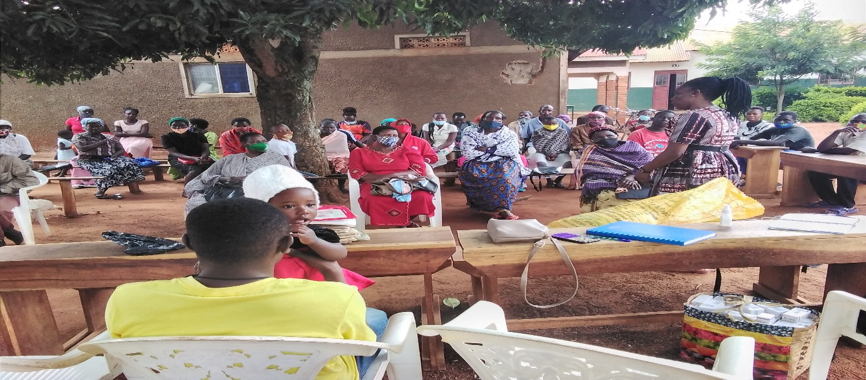

Figure 1: Interacting with the caregiivers who turned up for the out reach clinic in Buwenege

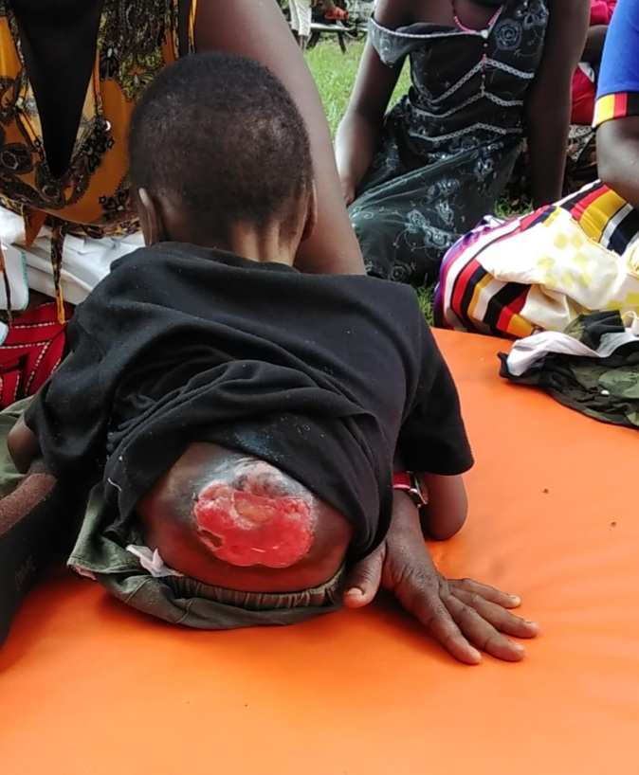

Figure 2: Kigenyi David has Spinal Bifida that caused the wound and was referred to One 4another for further management who later referred him to CorSU but they could not handle the situation and they also referred him to Cure Children’s hospital.

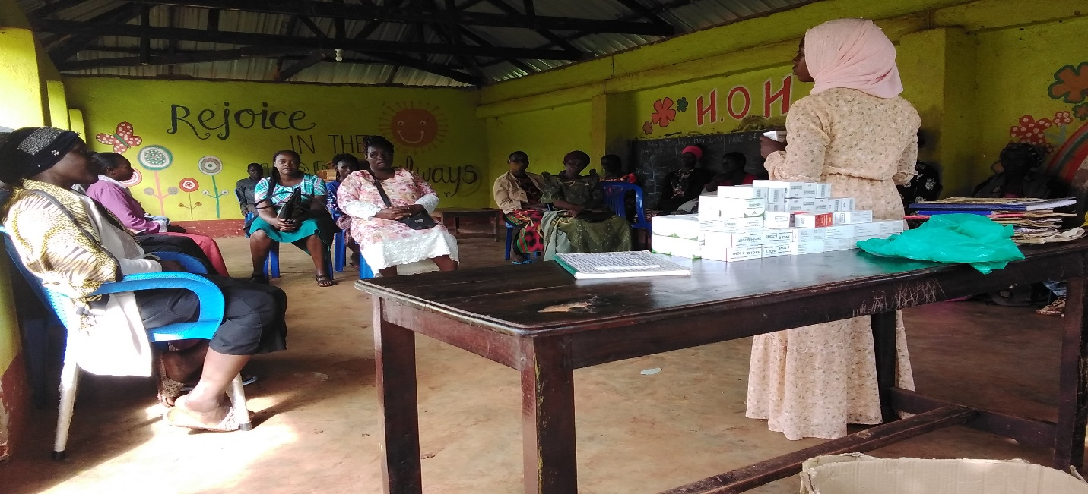

Figure 3: The ED making a presentation during the community dialogue in Busede Sub County

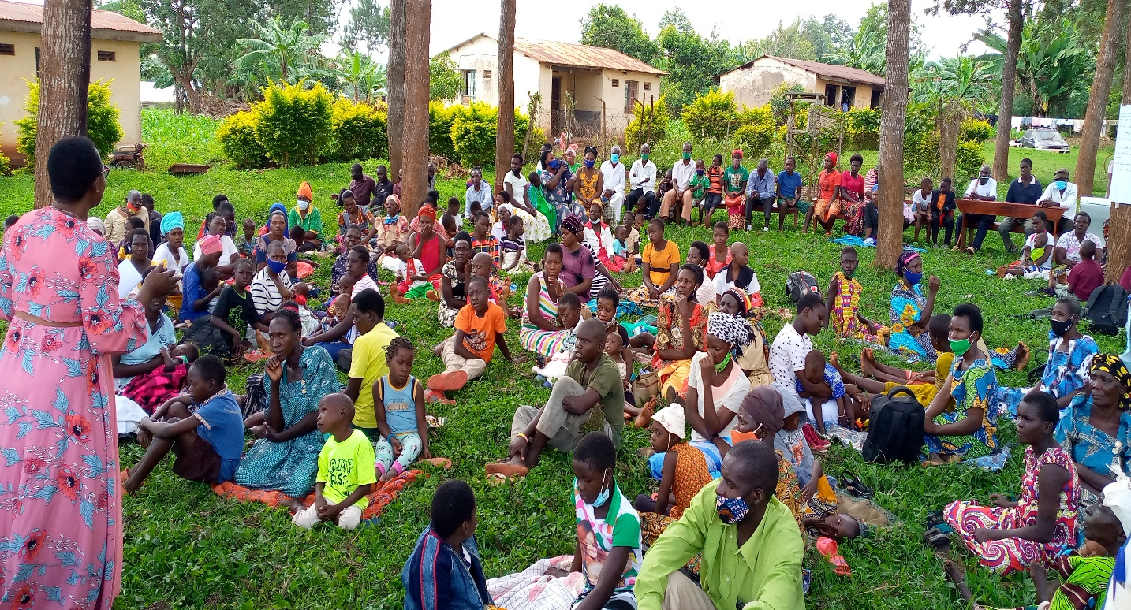

Figure 4 A cross section of the care givers and patients during the Centre General Clinic

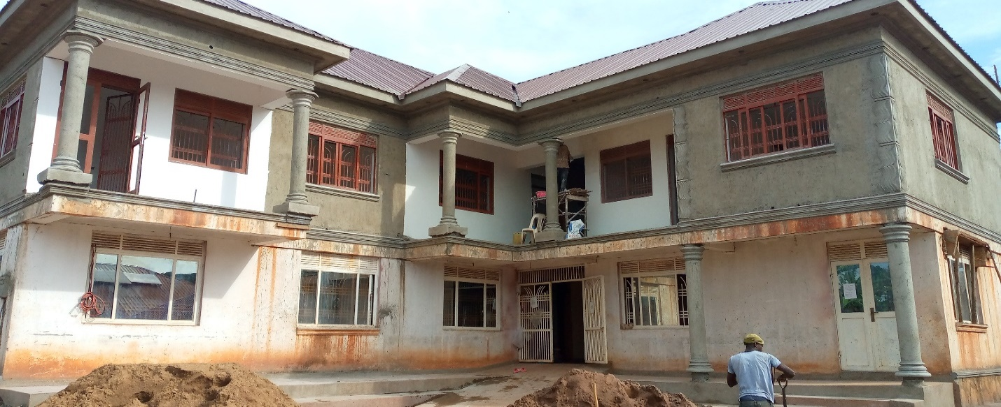

Figure 5: The current status of the construction works at the Guest wing

***Submitted by: EDITH LUKABWE***

***EXCUTIVE DIRECTOR****CDO ratingcommunity mmilia on 22 sharing out.resher traning ber 2018 for their communities with the help of other stake holders.*